**Personal Portfolio Template**

Group 96

Alexander Erickson – N9958541

https://github.com/hughdtt/IFB299-Team96

**Artefact 1** – Physical Design Diagram

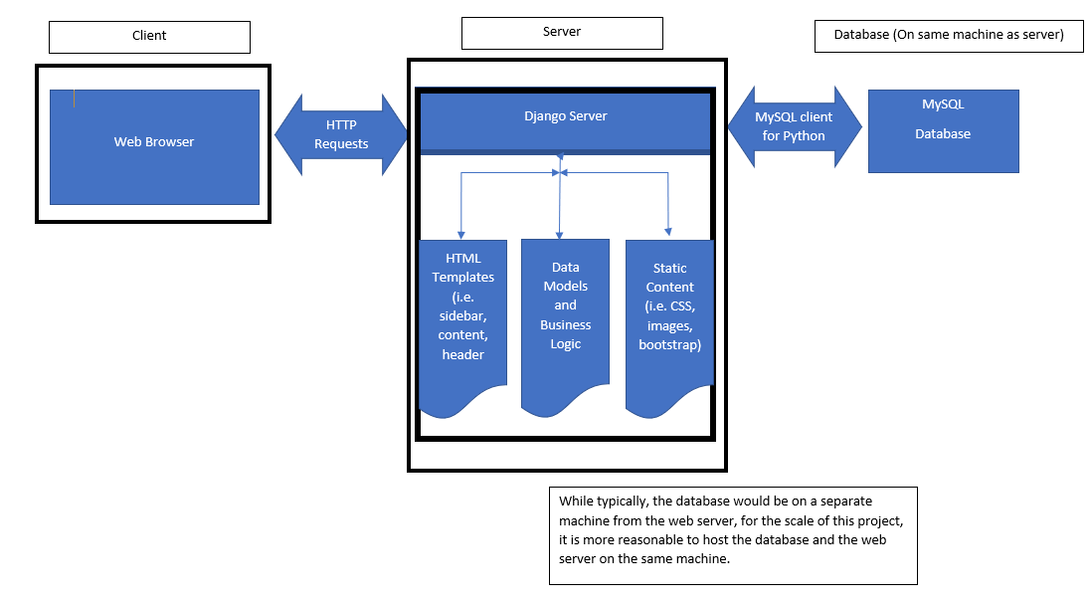

**Artefact 2** – Login Screen Mock-up

Created mock-up for the user logon screen.

The mock-up of the logon screen was used to guide the development of the actual design for the login screen.

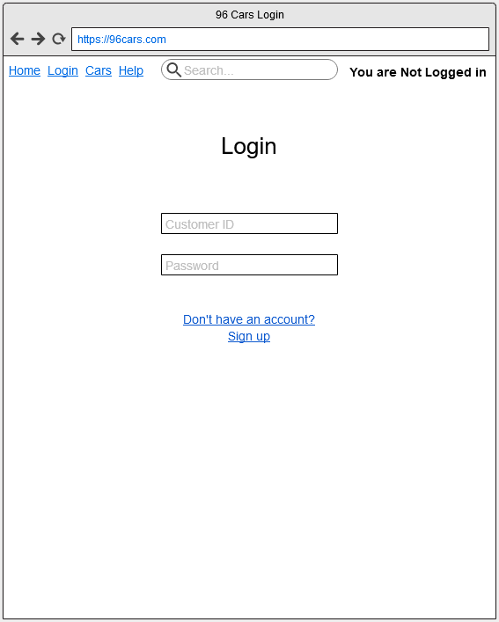

**Artefact 3** – CSV import code

The CSV import code is a function which imports a provided CSV file and converts it into data entries in the application’s database.

The CSV import code was used in order to import the existing database for the car rental website, stored as a CSV, into the application for use by the website. It saved a large amount of time when compared with importing it manually, either by hand or via a database tool, as it is included within the application and not outside of it.

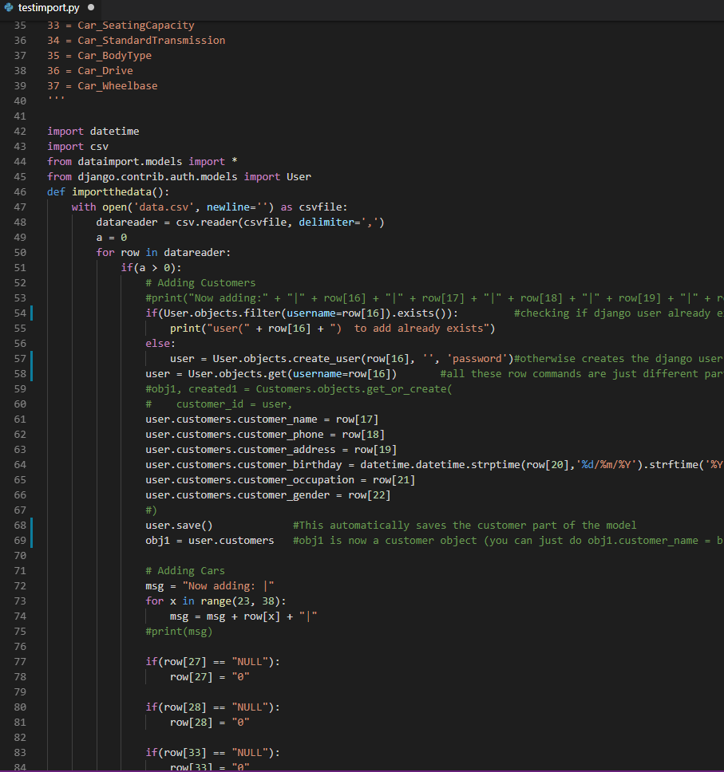

**Artefact 4** – Justification for using three tier system

A document which explains why the three tier system was used for this project, describing how the Django framework is a three tier system.

The justification allowed the team to see the big picture of the project in a simplified manner, thus helping the team stay in synchronisation towards a common goal.

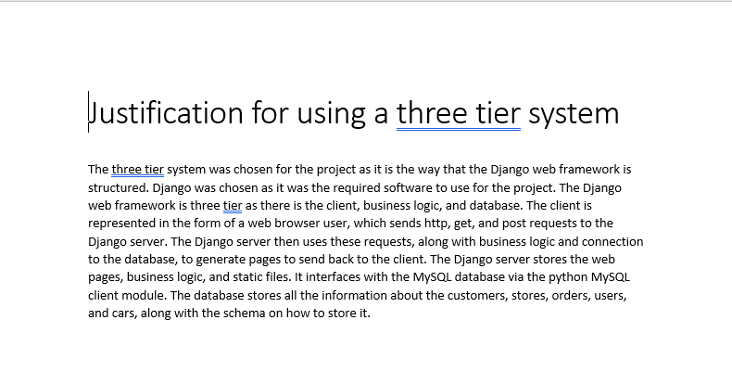

**Artefact 5** – Database structure

A collection of python scripts which Django uses that describe the structure of the database.

The database structure scripts were used by Django to create the database, allowing data about the customers, stores, orders, and cars to be stored and retrieved in the database in the correct manner.

